**Life’s Moments: Emails  
  
1. Trial Ended**

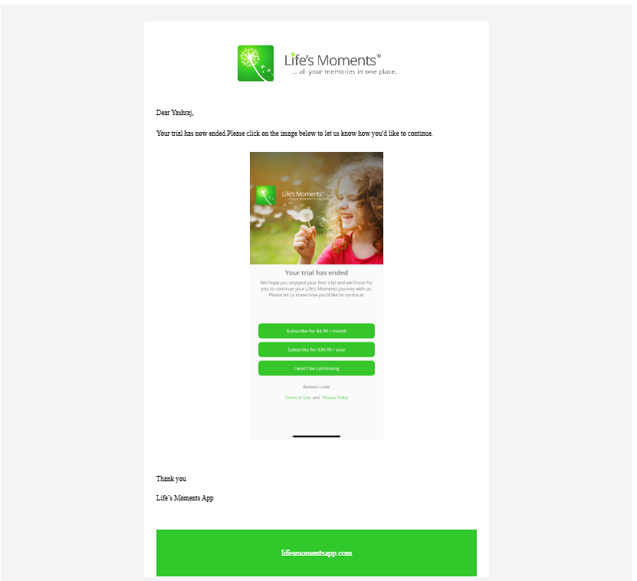

1. **Trail About to End**

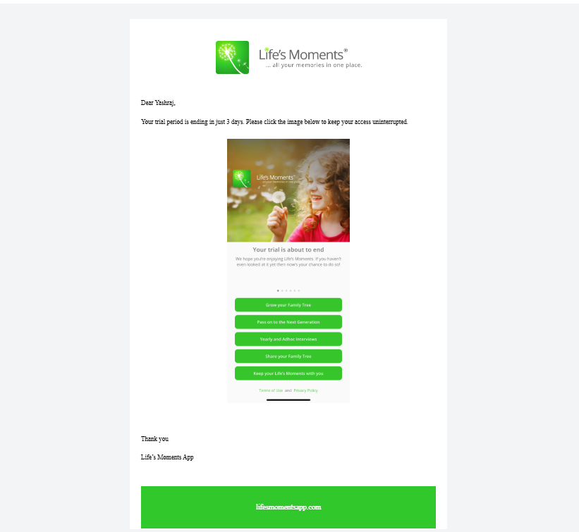

1. **Bulk Download**

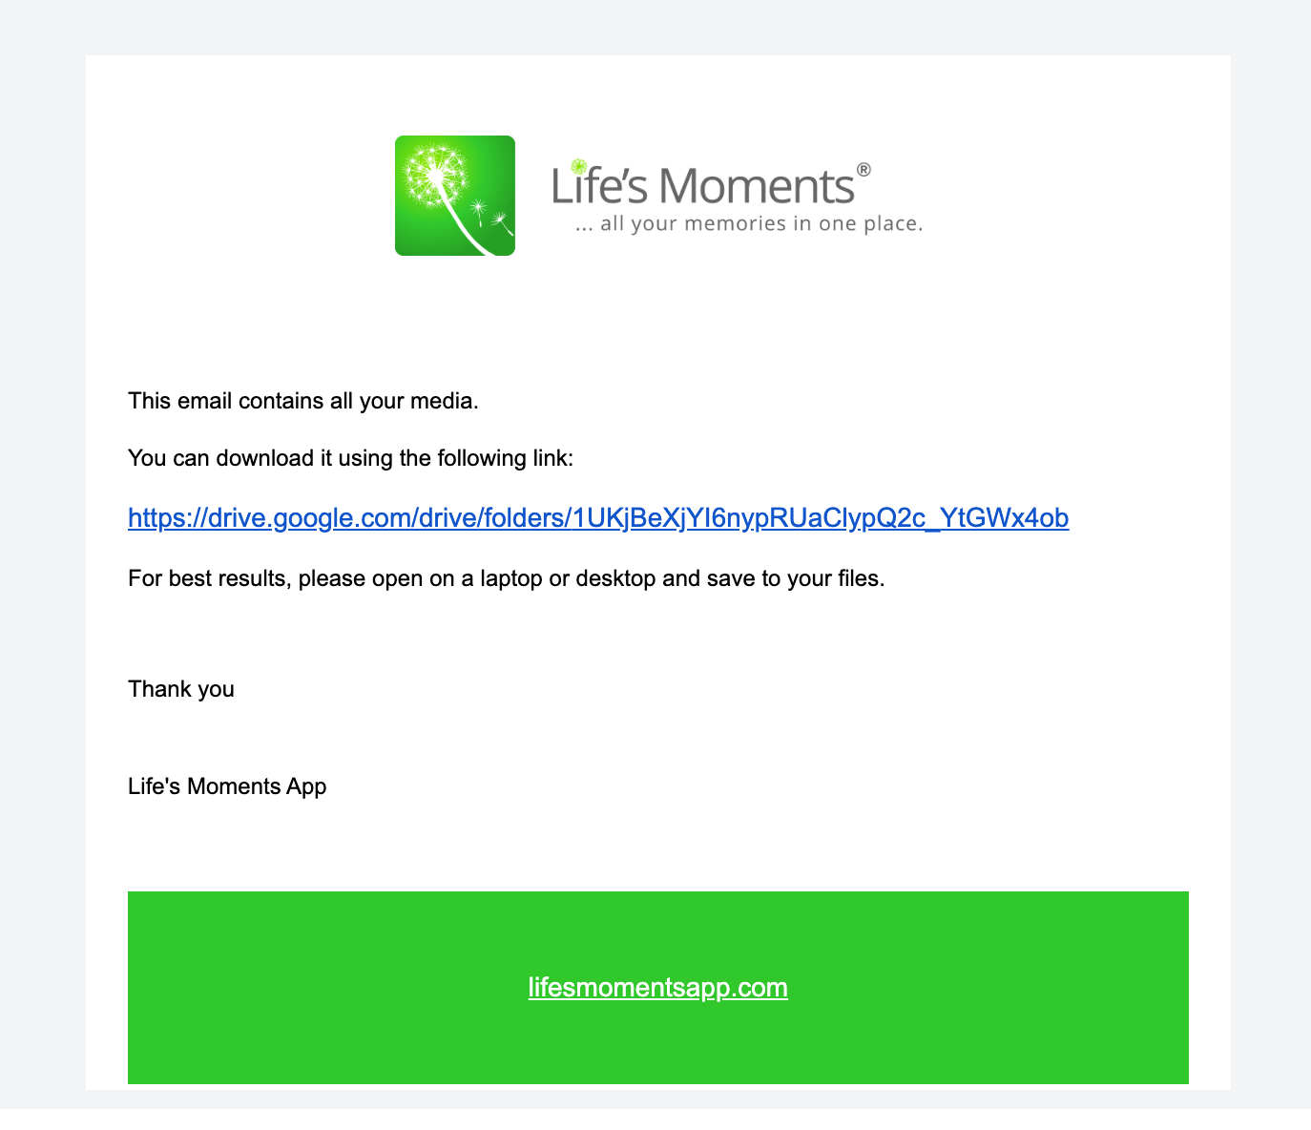

1. **Guest User Access 1 ➖**

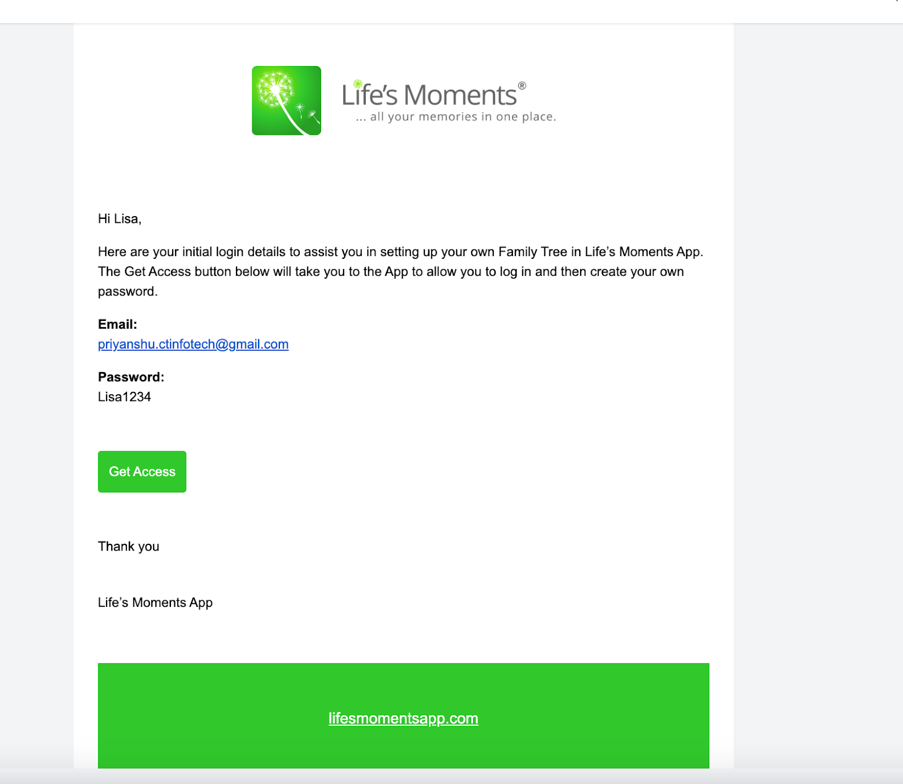

1. **Guest User Access 2:-**

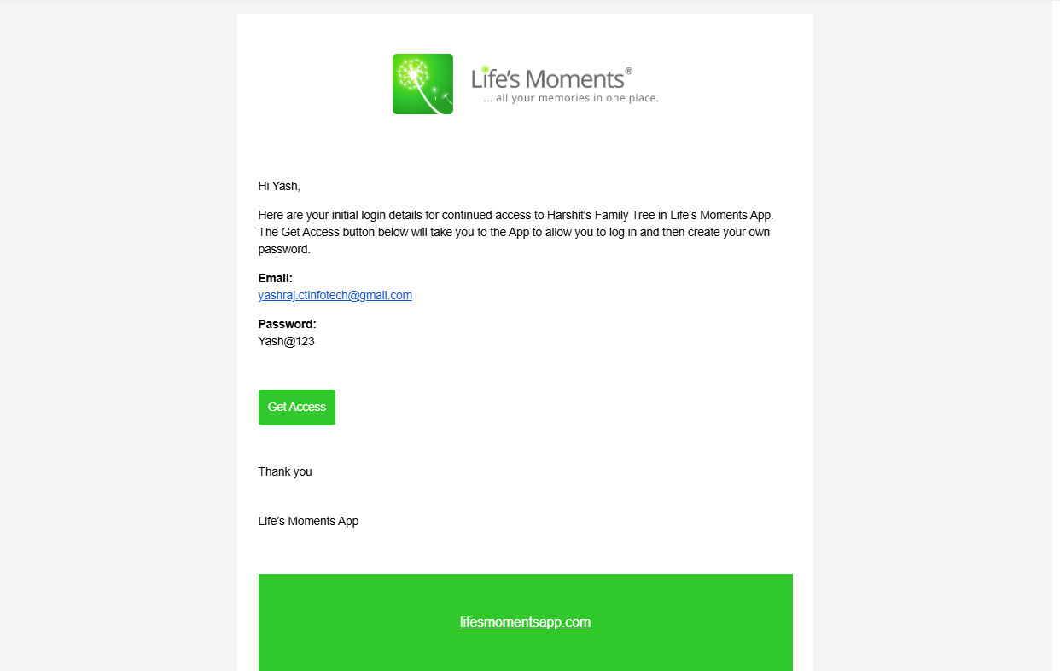

**6 Password Reset :-  
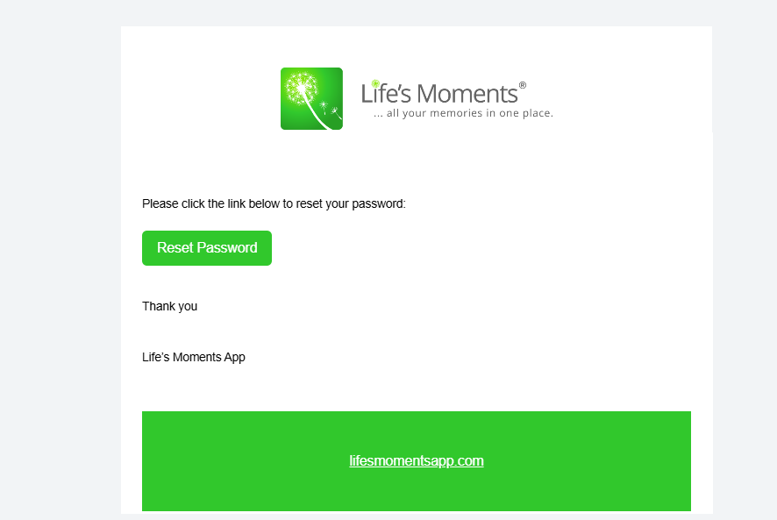**

**7. Feedback : -**

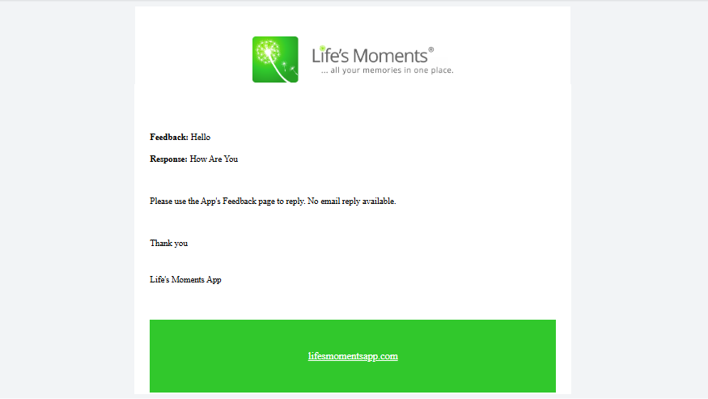

**8. Broadcast :-**

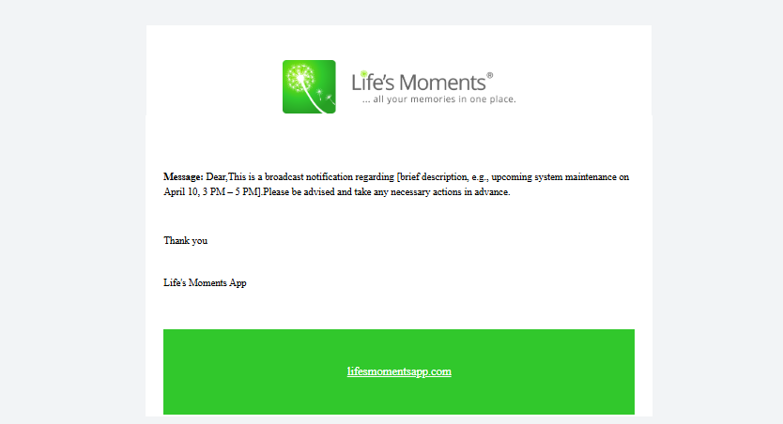

**9. Interview 24 hours before :-**

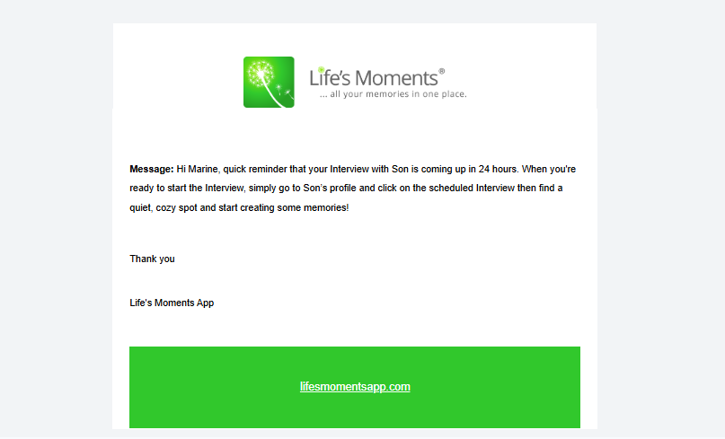

**Firstly… drop the words Hi Marine down two lines so it appears where the word quiet currently sits *** Same for ALL EMAILS**

**Add**

**Green Button with White text centrally located between**

**Some memories!**

**Start Interview (button) **** Please match the Life’s Moments green to the button as per the Get Access buttons above**

**Thankyou**

**Life’s Moments App**

**\*\*\* Opens to the persons album page/interviews/THE INTERVIEW that is Due… opens to the page where the Start Interview button is located.**

**10. Interview 72 hours before :-**

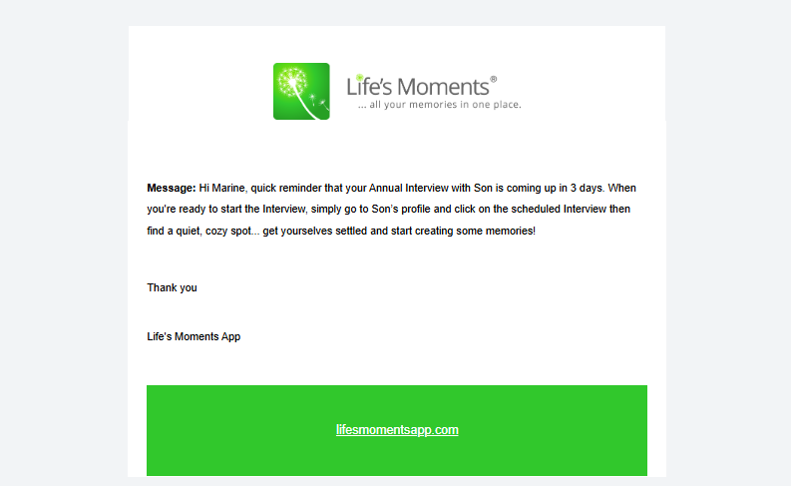

**Green Button with White text centrally located between**

**Some memories!**

**Start Interview (button)**

**Thankyou**

**Life’s Moments App**

**\*\*\* Opens to the persons album page/interviews/THE INTERVIEW that is Due… opens to the page where the Start Interview button is located.**

**11. Interview 30 days before :-**

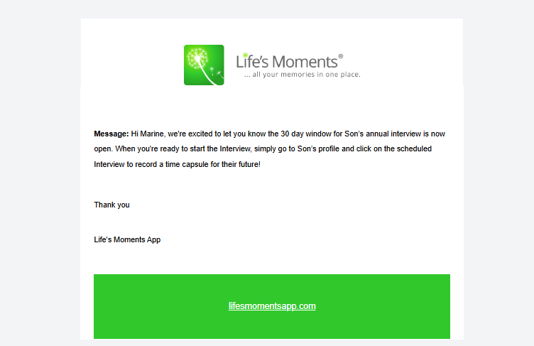

**12. After added 10 more photos / videos :-**

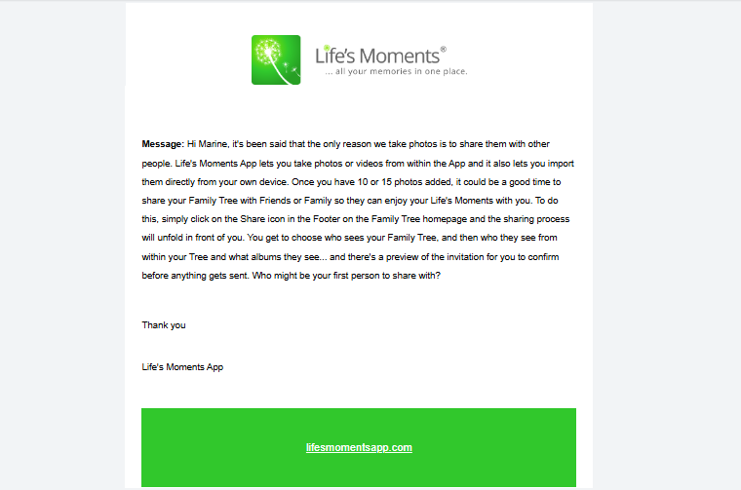

**Green Button with White text centrally located between**

**first person to share with?**

**Give sharing a try (button)**

**Thankyou**

**Life’s Moments App**

**Opens to the First Screen in the Sharing process… so process can be followed**

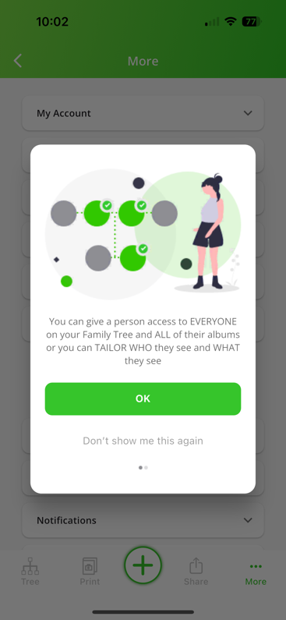

**13. After 3 days creating a profile without no photo :-**

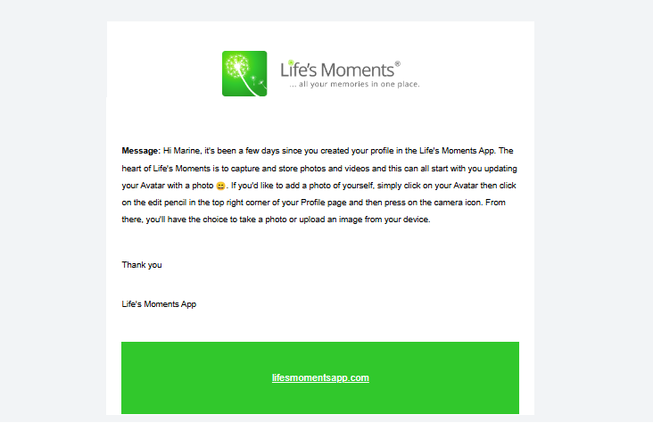

**Green Button with White text centrally located between**

**upload an image from your device**

**Add a photo of myself (button)**

**Thankyou**

**Life’s Moments App**

**Opens to the View Profile screen of the ADMIN person… so they can hit the edit pencil and the adding a photo process can be followed**

**14. After 7 days add person or pet without no photos :-**

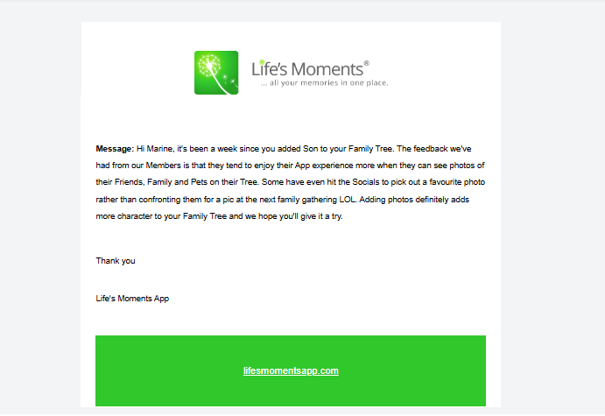

**Green Button with White text centrally located between**

**hope you’ll give it a try**

**Add a photo of Mail Merge (button) eg in this case Son**

**Thankyou**

**Life’s Moments App**

**Opens to the Edit Family Member screen of the Son Member’s page… to the Add a profile picture pop up screen so they can hit Take Photo or Upload Image and the adding a profile photo process can be followed**

**15. After 72 hours account created : -**

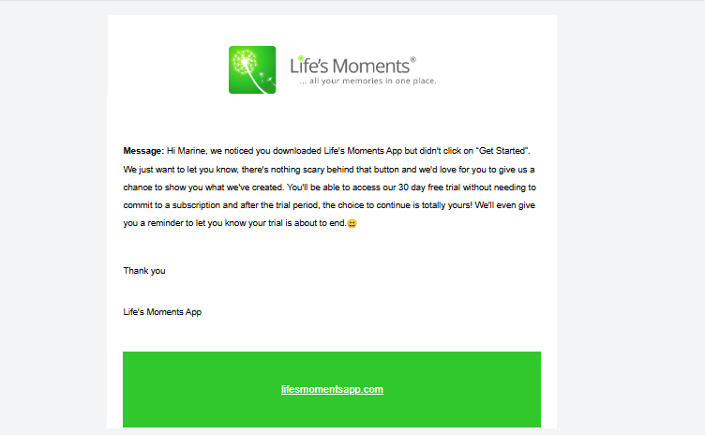

**Green Button with White text centrally located between**

**your trial is about to end**

**Give it a try (button)**

**Thankyou**

**Life’s Moments App**

**Opens to the Homescreen of the Family Tree with the Avatar or Photo of the person and Get Started button underneath**

**16. 24 Hours after the clicked into the 101.0 page and Didn't Choose one of the options :-**

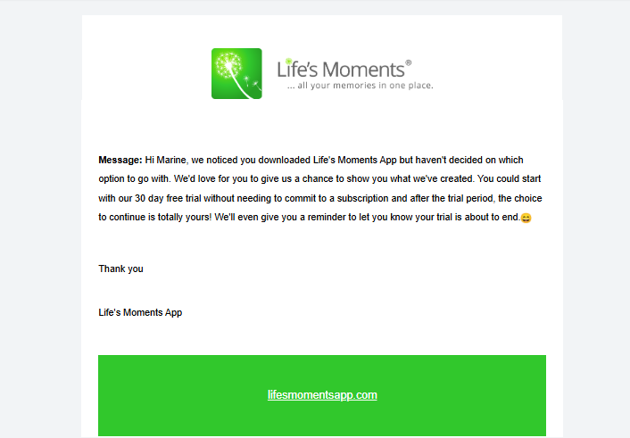

**Green Button with White text centrally located between**

**your trial is about to end**

**Give it a try (button)**

**Thankyou**

**Life’s Moments App**

**Opens to the Subscription Choice screen 101.0 in XD**

**17. 24 Hours after the clicked into the 101.5 page and Didn't Choose one of the options :-**

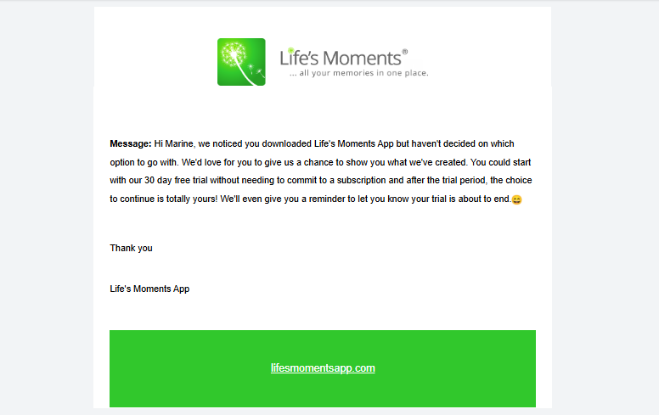

**Green Button with White text centrally located between**

**your trial is about to end**

**Give it a try (button)**

**Thankyou**

**Life’s Moments App**

**Opens to the Subscription Choice screen 101.5 in XD**